Essay on Wildlife Conservation and Its Importance
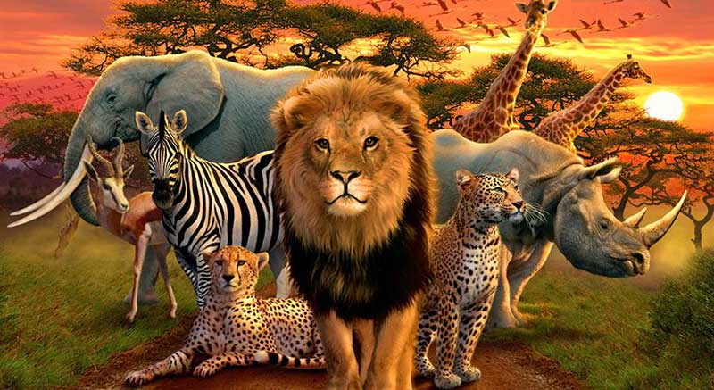
Wild animals are an important constituent of nature. In India, nearly 5 per cent of wild animals of the wild live in her various parts. Nearly 76,000 species (out of the 1,30,00,000 wild life species of the world) are found in India. Among these species, there are 340 mammals, l,20() birds, 420 reptiles, 140 amphibians, 50,000 insects, 4,000 moluscs and nil invertebrates. These figures are of numbers of various species. India is one of those twelve nations that have maximum bio-diversity.

The area of her land is 32,87,263 square kms. Besides, this region has been endowed with a coastline of 7,516 kms, large perennial river systems, lakes, mountain ranges (like the Great Himalayas), Thar desert, swamps, archipelagoes and various types of vegetation.

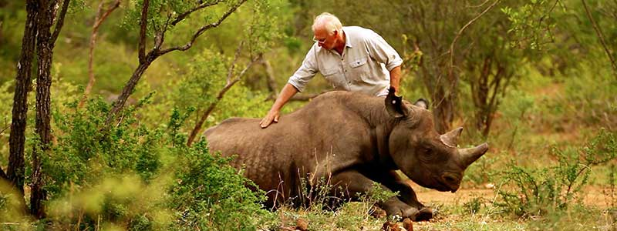
To the utter dismay of the entire world, the wild life is being destroyed at a very quick pace. Two reasons can be cited for this destruction: (a) natural reasons; and (b) human reasons. Although both these types of reasons are responsible for the destruction of the wild life, yet natural reasons have proved to be less harmful than human reasons. That is because natural factors destroy the wild life at a slow pace. The first-ever demolition of wild animals (or species) by natural factors was done nearly 70 million years ago. In the present times (starting from the seventeenth century to date), nearly 120 species of mammals (who were birds) have become extinct. The list of those birds, who became extinct during the past 200 years, includes Dodo (of Mauritius), Sarcohayenkera (of Florida) Avetopickete (of South America), Migratorius (of the pigeon category) and Panthera Leo Melenochitus (of Florida).

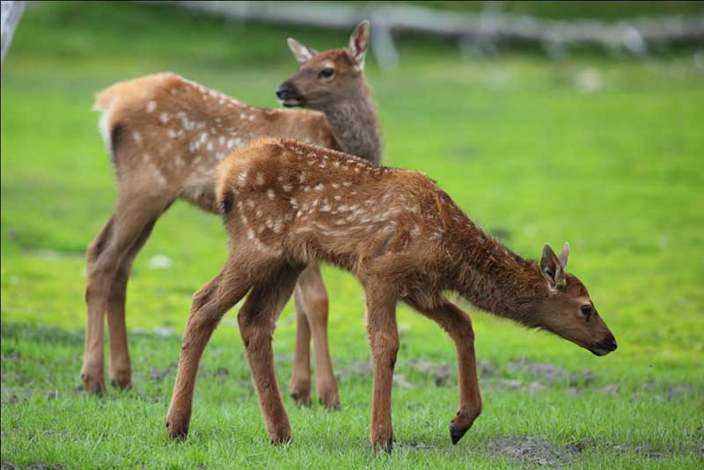
In India, the hill quail, small-sized rhinoceros and the duck with a pink head have become extinct. Human reasons play the most important roles in the process of destruction of wildlife. Human reason include deforestation and senseless exploitation of natural resources of the earth. Because of this, there is a reduction in the number of natural habitats for wild animals. Several species have either disappeared or are on the verge of extinction. According to a report by the UNO, nearly 10,000 species (of the total 1,30,000 species of all the wild animals of the world) are either extinct or on the verge of being extinct.

In our country, Wild Elephant Protection Act was passed in 1872 to prevent the wild animals from becoming extinct. After this, Indian Forest Act (1927) was created; according to its provisions, hunting of wild animals and cutting of forests were declared as punishable crimes.

After independence, the Government of India established Indian Board for wild life. In 1956, Indian Forests Act was passed. In 1972, Indian Wild Life Protection Act was passed. It is a broadbased central law, which has provisions for protection of animals that face the threat of becoming extinct or are almost extinct.

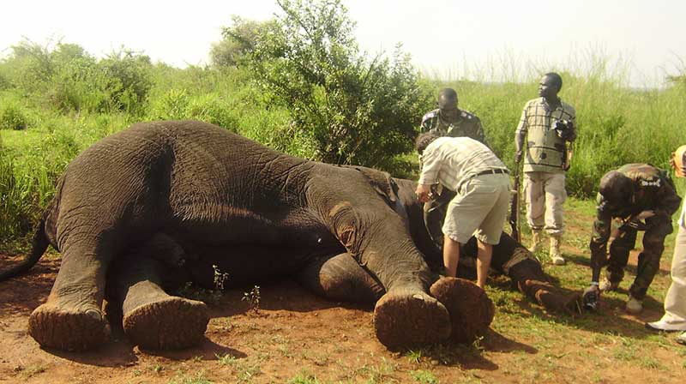
For protecting the wild animals, the Forty-Second Constitution (Amendment) Act (1976) was passed to add two new Articles (48-A and 5 1(A) (G)) to the Constitution. Thus, the issues related to wild animals were added to the concurrent list after this amendment. National Wild Life Scheme was started in 1983 to improve the deteriorating conditions of wild animals and ensure their protection.

In India, the development of national parks and wild life sanctuaries during the past two decades indicates that our government is committed towards wild life protection and conservation. In 1935, we had only one national park but today, the number of national parks in the entire nation is 102. The maximum number of national parks is in Madhya Pradesh. The total number of wild life sanctuaries is 515; these are located at 4.5 per cent of the total area of the country.

It is pleasing to note that encouraging results have been obtained after making efforts to conserve wild life. For protecting wild life, the efforts of the government would have to be coupled with the process of enlightening all the sections of Indian society. We will have to protect the silent, harmless wild animals from nature and poachers.

Read here All Essay of student
http://www.english.makeaneasy.com/essay-wildlife-importance/
Searches related to essay on wildlife conservation importance of wildlife conservation wikipedia, essay on save wildlife 150 words, articles on wildlife conservation, essay on wildlife protection, short essay on wildlife, essay on wildlife and its importance, importance of wild life, ways to protect wildlife essay, article on importance of wildlife, article on save wildlife save earth, short essay on wildlife conservation, paragraph on wildlife conservation, short article on wildlife conservation, newspaper articles on wildlife conservation, paragraph on wildlife protection, importance of wildlife essay, essay on save wildlife 100 words, wildlife conservation essay,

