Essay on Population Growth and Its Effects in English

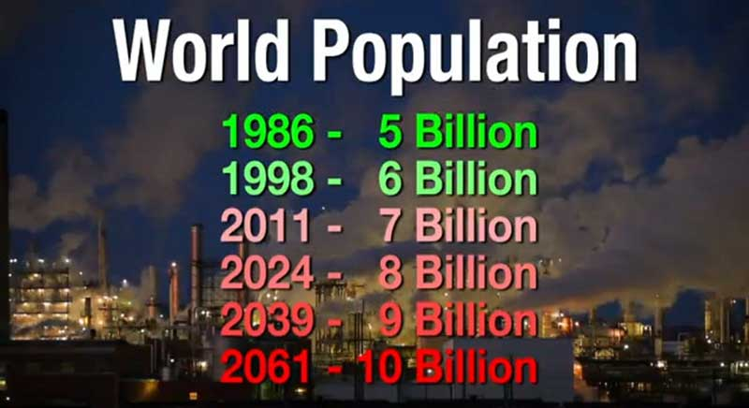
The final data of the 15th Census of India - 201 1 has been presented by the Registrar General and Census Commissioner C. Chandremauly on 31st March. The Census data, this time, has presented a changed scenario of the country. The population has indeed increased but the rate of increase has lowered. As per the new Census, India’s population, on 1st March, 2011, has become 1,21,05,69,573.

In this way, Indian population has increased by 18.15 crores (17.7 per cent) during 2001-11. As per census-20 11 data, the male population in India is 62,31,21,843 and that of females is 58,74,47,730. In comparison with year 2001, the rate of increase has lowered by 3.9 per cent. This time the gender ratio has improved on the national level but it has drastically worsened for those below six years of age.

This ratio has decreased to 914 from 927 females for per 1000 male children. While at the national level, these are now 943 females for every 1000 males; the previous figure being 933 female. Since detailed Census data on birth rates and migration are not yet available, it is not possible to say whether this decline is being driven by sharply reduced fertility in the states or high out-migration of people to other states and metropolitan cities. Indeed overall fertility is declining in India.

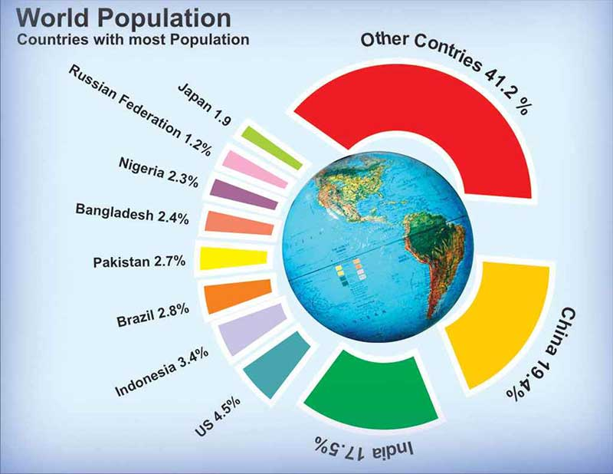
As more and more people have been migrating into the national capital over many years, Delhi has become the most density-populated city in India with 11,320 persons per square kilometre. The figure was 9,340 in 2001. Delhi’s population has reached 1.68 crores now with an increase of 29 lacs people in last 10 years.

Uttar Pradesh is the most populated state (19.98 crores) and Sikkim is the least populated (6.10 lacs) state in India. The sum of the populations of Uttar Pradesh and Maharashtra surpasses that of America. The present population of India is 2 billion equals the total population of America, Indonesia, Brazil, Pakistan, Bangladesh and Japan. In other words, the world’s 17.5 per cent population lives in India. It will not be wrong to state that in future India will surely beat China also at least, in this context.

The one important aspect of the current Census is the improvement in the gender ratio. There are 943 females per 1000 male in this decade as against 933 females per 1000 males in the last decade. Notorious for female foeticides - Haryana, Punjab, Delhi and Chandigarh recording growth in number of women against men, is a positive sign. The highest gender ratio is in the state of Kerla and the lowest is in Haryana. The national literacy rate has improved and has increased by 10 per cent over the last decade. There are approximately 80.9 per cent literate males and 64.6 per cent literate females. During the decade, female literacy rate has increased by 11.8 per cent and that of males by 6.9 per cent. Highest literacy rate (94.0%) is in Kerla and the lowest (61.8%) is in Bihar.

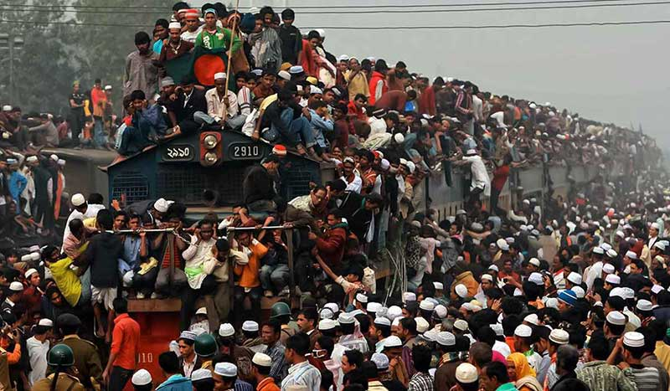
The lowering in children gender ratio is surely a matter of concern. In year 2001, there were 16 per cent children of 0-6 years category in the total population while in the year 2011 this has declined to 13 per cent. Another remarking feature of the census results shows that the percentage growth of six most populous states—Uttar Pradesh, Maharashtra, Bihar, West Bengal, Andhra Pradesh and Madhya Pradesh have declined, which shows another impact of improved literacy and economic growth. According to 2011 census, the total Indian population at the dawn of 1st March, 2011 was 121 crore. India accounts for a meagre 2.4% of the world surface area of 135.79 million sq. km. Yet, it supports and sustains a whopping 17.5% of the world population.

Conclusively, we can say that our population is not a burden over our country but it is a human resource. With this mindset only, we can move ahead on the way to progress.

Essay on Population Growth and Its Effects in English
essay on population explosion and its effects, essay on population growth in india, simple essay on population, short essay on population growth, cause and effect essay on population growth, population growth essay in english, population essay topics, population growth college essay, short essay on population explosion, essay on population growth and its effects, essay on increasing population, population essay in english pdf, essay on increasing population in hindi, essay on population explosion in 200 words, essay on population explosion in 150 words, essay on population explosion 250 words, essay on population explosion for class 8, population explosion essay pdf, essay on population explosion in hindi, speech on population explosion and its solution,

