All Tense Rule chart or Table in English

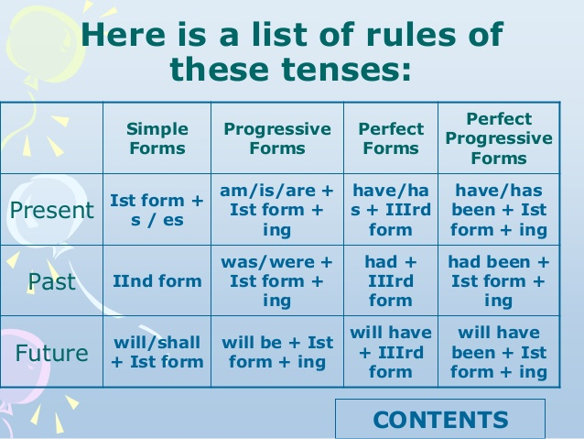

1. Simple Present Tense
Formula:
(+) S + V1 + O/C
(-) S + do/does + not + V1 + O/C
(?) Do/does + S + V1 + O/C

Find here Example of Simple Present Tense:
(+) Sisca reads book everyday.
(-) Sisca does not read book everyday.
(?) Does Sisca read book everyday?
Yes, she does. / No, she does not.

2. Present Continuous Tense
Formula:
(+) S + be + V1 + ing + O/C
(-) S + be + not + V1 + ing + O/C
(?) Be + S + V1 + ing + O/C

Find here Example of Present Continuous Tense:
(+) He is playing badminton now
(-) He is not playing badminton now
(?) Is he playing badminton now?
Yes, he is. / No, he is not.

3. Present Perfect Tense
Formula
(+) S + has/have + been + O/C
S + has/have + V3 + O/C
(-) S + has/have + not + been + O/C
S + has/have + not + V3 + O/C
(?) Have/has + S + been + O/C
Have/has + S + V3 + O/C

Find here Example of Present Perfect Tense:
(+) He has been at home for a month.
Roni has eaten the steak already.
(-) He has not been at home for a month.
Roni has not eaten the steak already.
(?) Has he been at home for a month?
Has he eaten the steak already?
Yes, he has. / No, he has not.

4. Present Perfect Continuous Tense
Formula:
(+) S + have/has + been + V-ing
(-) S + have/has + not + been + V-ing
(?) Have/has + S + been + V-ing

Find here Example of Perfect Continuous Tense:
(+) He has been playing guitar for two hours.
(-) He has not been playing guitar for two hours.
(?) Has he been playing guitar for two hours?
Yes, he has. / No, he has not.

5. Simple Past Tense
Formula:
(+) S + to be (was/were) + O/C
S + V2 + O/C
(-) S + to be (was/were) + not + O/C
S + did not + V1 + O/C
(?) Did + S + V1 + O/C

Find here Example of Simple Past Tense:
(+) He was a businessman in 1999.
He visited me yesterday.
(-) He was not a businessman in 1999.
He did not visit me yesterday.
(?) Did he visit you yesterday?
Yes, he did. / No, he did not.

6. Past Continuous Tense
Formula:
(+) S + to be (was/were) + V-ing + O/C
(-) S + to be (was/were) + not + V-ing + O/C
(?) Was/were + S + V-ing + O/C

Find here Example of Past Continuous Tense:
(+) She was sleeping when I came.
(-) She was not sleeping when I came.
(?) Was she sleeping when you came?
Yes, she was. / No, she was not.

7. Past Perfect Tense
Formula:
(+) S + had + V3 + O/C
(-) S + had + not + V3 + O/C
(?) Had + S + V3 + O/C

Find here Example of Past Perfect Tense:
(+) He had gone to Bali when I called him.
(-) He had not gone to Bali when I called him.
(?) Had he gone to Bali when you called him?
Yes, he had. / No, he had not.

8. Past Perfect Continuous Tense
Formula:
(+) S + had + been + V-ing + O/C
(-) S + had + not + been + V-ing + O/C
(?) Had + S + been + V-ing + O/C

Find here Example of Past Perfect Continuous Tense:
(+) They had been living in Jakarta about ten years.
(-) They had not been living in Jakarta about ten years.
(?) Had they been living in Jakarta about ten years?
Yes, they had. / No, they had not.

9. Simple Future Tense
Formula:
(+) S + will/shall + V1 + O/C
S + am/is/are + going to + V1 + O/C
(-) S + will/shall + not + V1 + O/C
S + am/is/are + not + going to + V1 + O/C
(?) Will/shall + S + V1 + O/C
Am/is/are + S + going to + V1 + O/C

Find here Example of Simple Future Tense:
(+) She will eat fried rice.
She is going to eat fried rice.
(-) She will not eat fried rice.
She is not going to eat fried rice.
(?) Will she eat fried rice?
Is she going to eat fried rice?
Yes, she will. / No, she will not.
Yes, she is. / No, she is not.

10. Future Continuous Tense
Formula:
(+) S + will/shall + be + V-ing + O/C
(-) S + will/shall + not + be + V-ing + O/C
(?) Will/shall + S + be + V-ing + O/C

Find here Example of Future Continuous Tense:
(+) I will be watching a movie tonight.
(-) I will not be watching a movie tonight.
(?) Will you be watching a movie tonight?
Yes, I will. / No, I will not.

11. Future Perfect Tense
Formula:
(+) S + shall/will + have + been + C
S + shall/will + have + V3 + O
(-) S + shall/will + not + have + been + C
S + shall/will + not + have + V3 + O
(?) Shall/will + S + have + been + C
Shall/will + S + have + V3 + O

Find here Example of Future Perfect Tense:
(+) I will have been in this hospital until tomorrow morning.
He will have rented my house next month.
(-) I will not have been in this hospital until tomorrow morning.
He will not have rented my house next month.
(?) Will you have been in this hospital until tomorrow morning?
Will he have rented my house next month?
Yes, I will. / No, I will not.
Yes, he will. / No, he will not.

12. Future Perfect Continuous Tense
Formula:
(+) S + shall/will + have + been + V-ing + O
(-) S + shall/will + not + have + been + V-ing + O
(?) Shall/will + S + have + been + V-ing + O

Find here Example of Future Perfect Continuous Tense:
(+) She will have been visiting us tomorrow.
(-) She will not have been visiting us tomorrow.
(?) Will she have been visiting us tomorrow?
Yes, she will. / No, she will not.

13. Past Future Tense
Formula:
(+) S + should/would + be + O
S + should/would + V1 + O
(-) S + should/would + not + be + O
S + should/would + not + V1 + O
(?) Should/would + S + be + O
Should/would + S + V1 + O

Find here Example of Past Future Tense:
(+) I should be in Banten next month.
I should be pick up when you arrive at the station next week.
(-) I should not be in Banten next month.
I should not be pick up when you arrive at the station next week.
(?) Should you be in Banten next month?
Should you be pick up when you arrive at the station next week?
Yes, I should. / No, I should not.

14. Past Future Continuous Tense
Formula:
(+) S + should/would + be + V-ing + O
(-) S + should/would + not + be + V-ing + O
(?) Should/would + S + be + V-ing + O

Find here Example of Past Future Continuous Tense:
(+) My brother would be finishing thesis last week.
(-) My brother would not be finishing thesis last week.
(?) Would your brother be finishing thesis last week?
Yes, he would. / No, he would not.

15. Past Future Perfect Tense
Formula:
(+) S + should/would + have + been + C
S + should/would + have + V3 + O
(-) S + should/would + not + have + been + C
S + should/would + not + have + V3 + O
(?) Should/would + S + have + been + C
Should/would + S + have + V3 + O

Find here Example of Past Future Perfect Tense:
(+) My mother should have been here at nine o’clock tomorrow.
Marry would have worked in leading companies next month.
(-) My mother should not have been here at nine o’clock tomorrow.
Marry would not have worked in leading companies next month.
(?) Should your mother have been here at nine o’clock tomorrow?
Would Marry have worked in leading companies next month?
Yes, she should. / No, she should not.
Yes, she would. / No, she would not.

16. Past Future Perfect Continuous Tense
Formula:
(+) S + should/would + have + been + V-ing + O
(-) S + should/would + not + have + been + V-ing + O
(?) Should/would + S + have + been + V-ing + O

Find here Example of Past Future Perfect Continuous Tense:
(+) I would have been working in leading companies for 10 years.
(-) I would not have been working in leading companies for 10 years.
(?) Would you have been working in leading companies for 10 years?
Yes, I would. / No, I would not.

Download here All Tense Rule in PDF format
For more Essay or Paragraph visit here http://www.english.makeaneasy.com

