A Visit to A Hill Station Short Essay

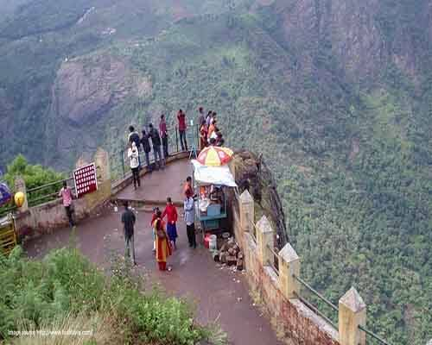

A hill station is a beautiful place to visit. During my summer vacation, i want to shimla. My uncle lives there. He invited me to spend my holidays in shimla. I boarded the shimla mail and reached there early in the morning.

After kalka the train moved very slowly. It passed through many tunnels. It moved like a snake. I was happy to enjoy the natural scenery and high mountains. But the view at shimla was very charming.

There wear ridge, chotta shimla, lakkar bazar, the temple of jakkhu. I visited kufri and had a view of snow. When i returned home. I brought fruits and beautiful presents. Its memory is green in my mind.

Download here A Visit to A Hill Station Short Essay in PDF

For more essay or story visit here http://www.english.makeaneasy.com

