A visit to a Zoo - Short Essay or Paragraph in English

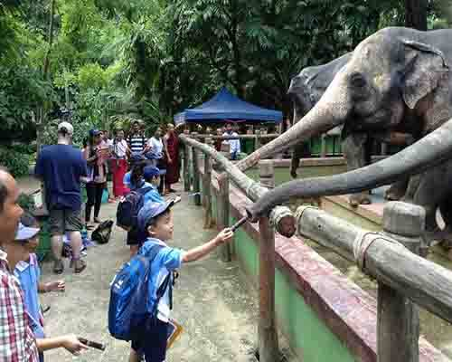
Zoo is a place where birds and animals of different kinds and colours are kept. A visit to the zoo is always very interesting. It adds to our knowledge. Only yesterday, my friends and i went to see the zoo.
It is housed in purana quila in New Delhi. First of all we saw water-birds, dusks and cranes in a pond. On the side were apes and monkeys in different cages. The monkeys were jumping on the branches of the trees. In order cages lions, tigers, wolves, bears, foxes and zebras were kept.
The lion was sleeping and the lioness was playing with cubs. They look very fearful. We also saw deer and langaroos. Then we came to the glass – houses. Birds and snakes or different kinds and colours were kept in them. Last of all we enjoyed an elephant ride and returned home.

Download here:
http://www.english.makeaneasy.com/category/paragraphs/

A visit to a zoo in Video in Video

A Visit to a Zoo Essay in PDF

Searches related to a visit to a zoo essay: a visit to a zoo essay for class 2, 1, 4, 5, 6, 7, 8, 9, a visit to a zoo essay 250 words, essay on visit to a zoo for class 7, short note on zoo, essay on visit to a zoo 100 words, zoo description essay, essay on animals in captivity should we keep animals in zoos essay zoos are cruel to animals essay best zoo to visit cool essay animals in captivity essay animals should not be kept in cages essay are zoos cruel to animals essay short essay on zoo for kids a trip to the zoo zoo parking fee are zoos good or bad for animals in the zoo

