Our School Library Short Essay for Student

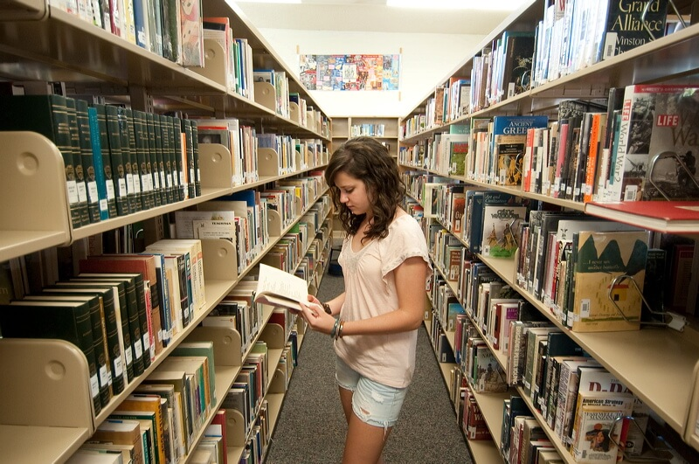

The library is a place where a large number of are kept. Our school library is housed in two big rooms. Bothe the rooms are airy and well-lighted. One room is reserved for book. Here books are arranged in almirah and shelves.
There are book on science, History etc. in Hindi and English. There is a large number of short story books. The other room serves as the reading room. Many students who do not find suitable atmosphere at home sit there for studies.
A part time librarian comes here in the morning during the school hours. He keeps the book in perfect order. He is very cooperative. After the school hours senior student looks after the library.

Download Here:

Our School Library Short Essay in PDF

http://www.english.makeaneasy.com/category/paragraphs/

Searches related to Our School Library Essay, 10 lines on my school library, essay on library in english, essay on school library for class 6, essay on my school library for class 8, my school library essay in hindi, essay on my visit to a library, paragraph on library in english, an hour in the school library essay, essay on school library essay on library wikipedia, uses of libraries, essay on libraries for 10th class, essay on library with quotations paragraph on library in english

