A Hot Summer Day Essay or Paragraph
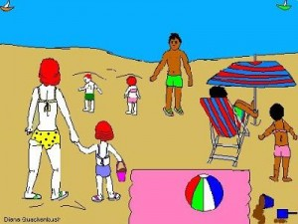
In Delhi summer is very hot. June and July are the hottest months of summer season. The sun shines brightly and the scorching heat is unbearable. Last year we experienced the hot waves. It was twenty fifth of June. People tried to remain inside the houses under the fan or cooler. They took shelter in dark room.
The frames stopped their work and lay down under the trees. The afternoon was the hottest part of day. People were perspiring from head to foot. Birds took shelter in the trees. Dogs could be seen with their tongues panting for breath.
It was very close and stuffy. The streets and the bazaars looked deserted. The sun was shining and there was no relief .the night was also hot. People rolled in bed to have a wink of their eyes. But they could not sleep till mid – night. It was after two that we had a little sleep.

Download here:

A Hot Summer Day Essay in PDF
http://www.english.makeaneasy.com/category/paragraphs/
Searches related to A Hot Summer Day essay: essay on hot summer afternoon, a hot summer day story, essay on summer season for class 4, a hot summer day essay for class 8, essay on hot summer day in hindi, a hot summer day essay for class 7, studymode a hot summer afternoon, a hot summer day essay for class 2

