The Goose That Laid The Golden Egg Short Story With Pictures
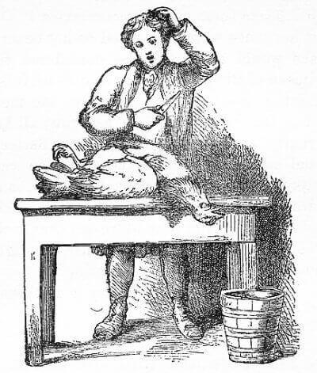
Once there lived a poor farmer in village. He had a large family. So he passed his days with great difficulty.
At last fortune smiled on him. He got a wonderful hen which laid a golden egg every day. He sold the egg and thus supported his family. Soon he becomes rich. But he was greedy. He thought of becoming rich overnight. He said to himself, “My hen must have gold inside. I should kill it and get all the gold at once.”
So he took a big knife and cut the hen’s stomach. He began to look for the gold. But he found no gold. He was now sad and disappointed. He repented of hid folly. He wept and cursed himself. But it was all useless. His greed ruined him.

Moral: Do not be greedy.
Download here other moral stories http://www.english.makeaneasy.com/category/stories/
Searches related to the goose that laid the golden egg story moral, golden goose story in english, the goose that laid the golden egg story pdf, the goose that laid the golden egg book, golden egg story video, the golden egg story with pictures, golden goose story pictures, the goose that laid the golden egg story moral, the golden egg story in english, the farmer and the golden egg story in hindi, the farmer and the magic goose story, the golden goose story summary, the hen that laid golden eggs story in english, the goose that laid the golden egg short story with pictures, the goose with the golden eggs short story, the goose with the golden eggs summary, the goose that laid the golden egg full story

