Two Friends and The Bear Short Story

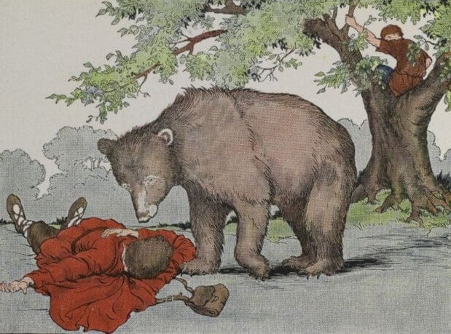
Once there lived two friends in a village. They were Mohan and Sohan. They set out on a journey. Their way lay through a forest. They promised to help each other.
On the way they saw a bear. He was coming towards them. They were frightened Mohan was selfish. He climbed up a tree. He hid himself there. But Sohan did not know how to climb up a tree. He knew that a bear does not eat a dead body. He lay down on the ground. He held his breath to look dead.
The bear came there. He smelt him all over. He took him for dead. He went away. Mohan came down. He said to Sohan, “What did the bear say in you hear?” Sohan said, “The bear advised me to beware of selfish friends.”
Moral: A friend in need, is a friend indeed.
Download Here:
http://www.english.makeaneasy.com/category/stories/
Two Friends and The Bear in PDF
Two Friends and The Bear in Video
Searches related to Two Friends and The Bear:
two friends and a bear story in hindi, two friends short story with moral, two friends story summary, the bear and the two friends author, story of two friends helping each other, two friends and a bear short story in hindi, story of two best friends, two friends short story pdf, two friends and the bear story with pictures, two friends and a bear story in hindi, two friends short story with moral, two friends story summary, the bear and the two friends author, story of two friends helping each other, two friends and a bear short story in hindi, two friends short story pdf, story of two best friends

