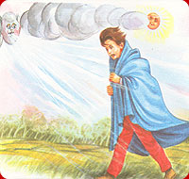
The Sun and The Wind Short Moral Story

Once there arose a quarrel between the sun and the wind. Each of them claimed to be the stronger than the other. They saw a traveler along the road. He was wearing a coat. They decided that one who could make traveler take off his coat, would be the stronger.
The wind tried first. It began to blow.By-and-by it gained speed. The traveler felt cold. The traveler said, “How cold it is! Let me tighten up my coat.” Thus the wind failed.
Now it was turn of the sun. It began to shine brightly. It grew hot. The traveler said “What change!” He perspired from head to foot. He took off his coat. Thus the sun was the winner.
Moral: Gentleness is better than force.
Download here other stories : http://www.english.makeaneasy.com/category/stories/
Searches related to the sun and the wind short story, story of dispute between the sun and the wind, the wind and the sun story pdf, the sun and the wind story in hindi, moral of the story the north wind and the sun, the sun and the wind story activities, the north wind and the sun story with pictures, the wind and the sun story with pictures, the wind and the sun story questions, the wind and the sun story telling, the wind and the sun story with moral

