The Bee and The Dove Short Story
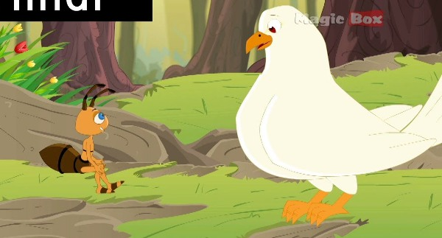
It was a hot summer day. A bee felt thirsty. It flew to a canal to drink water. By chance it fell into the canal. The current was very strong. It was washed away by the current. It became helpless.
A dove was sitting on the branch of a tree. She saw all this. She decided to save the life of the bee. She plucked a leaf. She dropped it near the bee. The bee got on it. Soon its wings dried and it flew away.
A few days later a hunter came there. He aimed at the dove. Luckily the bee swathe hunter. It flew to the hunter. It stung him on the hand. The hunter missed his aim. The dove flew away. She thanked the bee for this timely help.

Moral: Do good, find good. Or kindness never goes un-rewarded.

Download Here:

All Moral Story in PDF for Kids and Students

The Bee and The Dove Short Story in PDF

Searches related to ant and pigeon story moral, do good find good story, the pigeon and the bee story with pictures, what is the moral of the story the ant and the dove, pigeon and honey bee story, a bee falls into a tank, pigeon and bee story images, a bee falls into a tank story, the bee and the dove story with picture, ant and pigeon story in english, the dove and the bee full story in english, story of pigeon and ant with pictures, the ant and the dove story with dialogue, ant and dove story pdf, the ant and the dove comprehension questions, pigeon and ant story in english, ant and pigeon story moral, the ant and the dove story with pictures, the ant and the dove worksheet,

