My Motherland India - Essay on My Country for Student

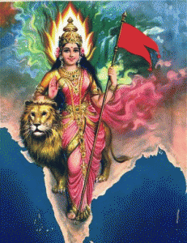
India is my motherland. It is a country of lakes, gardens, springs and hills. She has many rivers which irrigate her vast and fertile lands. Its civilization is as old as the history of the world.
My country stands for peace and freedom.
It is really a beautiful and rich country. My countrymen are the bravest in the world and the women here are kind-hearted, but strong willed.
I pray that no enemy may attack her borders and no citizen of hers be a victim of grief and pain. I shall be fortunate if I sacrifice my life for the safety of my motherland. It is great in peace, great in humanity and great in war. I am proud of it.

Download here:

My Motherland India Essay in PDF

Latest Essay http://www.english.makeaneasy.com/my-motherland/

Searches related to my motherland india essay, essay on my country for class 5, essay on my country india in english, india our motherland wikipedia, india my motherland poem, essay on mother india, motherland essay in hindi, india my motherland wikipedia, topic on my motherland, india our motherland ppt, india our motherland, by swami vivekananda

