My Favourite Sportsman Sachin Tendulkar: The Greatest Batsman in The World

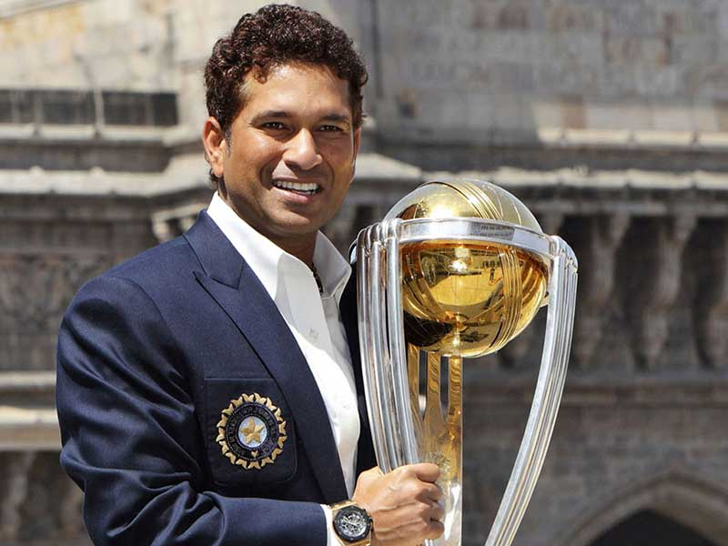

Sachin Tendulkar bade adieu to cricket on November 16, 2013 after remaining the stem of the foundation of Indian Cricket. He played his 200th and the last test match against West Indies at Wankhede Stadium of Mumbai. The government of India has honoured him with the ‘Bharat Ratna’, the highest citizen honour of India. The master-blaster, in his career of 24 years in cricket, has set many records to his credit.

This youngest son of a simple Marathi professor used to hold his bat in his hand and weave dreams of his future. His luck favoured him for the first time when Ramakant Achrekar, known as the Dronacharya of the cricket world, accepted, him as his disciple. The assayer eyes of Achrekar had visualised that this student (called Sachin) had come to learn from him from the core of his heart. The teacher had realised that one day, the bat of this student would sing such times as would make the cricket lovers of the world gyrate for long periods. Sachin also toiled hard along with Achrekar and at the age of thirteen years, he created history in partnership with his childhood friend, Vinod Kambli. Both of these players made a record partnership of 664 runs for the sixth wicket in school’s cricket competition. This was the first ever success of Sachin’s life, which acted like a tonic for him. After this his hunger for such achievements continued to grow.

Sachin had to wait for nearly five years to score the first century in one-day cricket matches. However, after scoring the first century, he liked the century scoring innings so much that he became engrossed in the efforts to score a century in every inning he played. The idea of Sachin’s growing hunger can be made through the fact that in 1994, Sachin, who had scored a century in seventy-ninth one-day match against Australia (in Colombo), had scored 49 centuries till December 23, 2012 when he bade adieu to it.

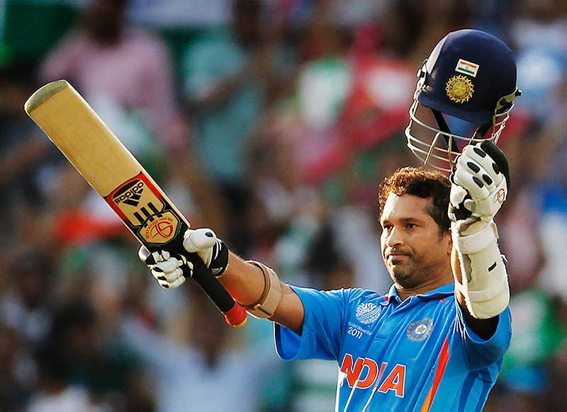

In his career of 24 years, Sachin has scored 18,426 runs in one-day games (with 49 centuries) and 15,921 runs (with 51 centuries) in Test matches.

On February 24, 2010 in Gwalior, Sachin became the first batsman in the world to score an unbeaten 200 runs in ODI. He made this record playing against South Africa. Sachin played more than 400 matches to setup this milestone. During this time period, he scored runs at the strike rate of 90. On 16 March, 2012 while playing in Asia Cup at Mirpur in Bangladesh against Bangladesh, Sachin completed his 100th century. The century of centuries has been completed in the history of cricket for the first-time. This was Sachin’s 49th century in the one-day matches. He has scored 51 centuries in test-cricket. Sachin has scored centuries against all the nations in the international cricket. The president while appreciating his contribution in the game has nominated him to Rajya Sabha. In the history of last sixty years, Sachin is the only sportsperson to be nominated for the Upper House.

Download Here:

More Essay for Students for All Classes
my favourite sportsman sachin tendulkar short essay, biosketch of sachin tendulkar in 80 words, essay on sachin tendulkar in 150 words, essay on sachin tendulkar in 200 words, essay on sachin tendulkar in 300 words, studymode essay on sachin tendulkar, essay on my favourite player ms dhoni, studymode essay on sachin tendulkar in 150 words, essay on my favourite player sachin tendulkar, essay on my favourite player in 300 words, 10 lines on sachin tendulkar, my favourite sportsman essay, describe your favourite sportsman essay, essay on sachin tendulkar, My Favourite Sportsman

