Role of Women in Economic Development of India
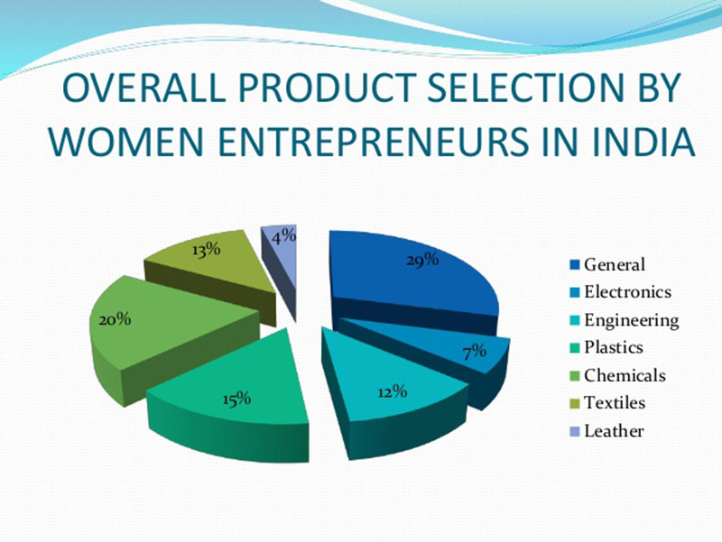
From pastoral society to contemporary information and global society, the role of women has changed drastically. The role of a typical ‘Grihani’ who catered to all the requirements of the household including the rearing and upbringing of children has been played quite efficiently. The continuity of changes in socio-economic and psycho-cultural aspects of human living has influenced the role of women.

During the Vedic times, Sita, Ahilya, Draupadi, Parvati and other women or goddesses became our idols due to their great sacrifices and virtues. During the medieval age in India, Meerabai, Chand Bibi, Razia Sultana, Padmini, Noor Jehan, Mumtaz Mehal, Jeeja Bai and Panna Dhai were the leading ladies who actively contributed in the social and political development of India. They tried to transform the contemporary Indian society through their virtues and actions. During the modern times, women of India also contributed towards the struggle for Indian independence. These included Bhikaji Cama, Aruna Asaf Ah, Sarojini Naidu, Annie Besant, Laxmi Bai of Jhansi, Begum Hazrat Mahal and Kasturba Gandhi.

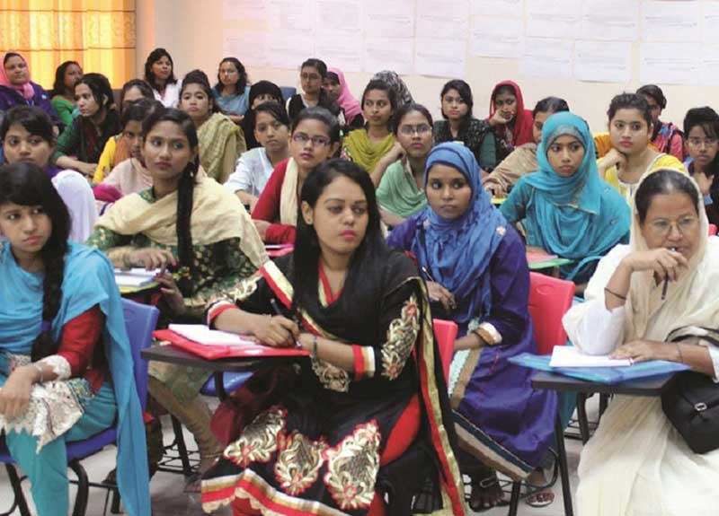

They also tried to transform the masses and enlighten them in social terms. Some of them fought against the Sati system too. With the process of industrialization, modernization and globalization showing its deep impact on the human society all over the world, the role and responsibilities of women has attained new definition and perspective. Further, this has also led to addition of responsibilities and dened the role of women who also shares the financial responsibilities.

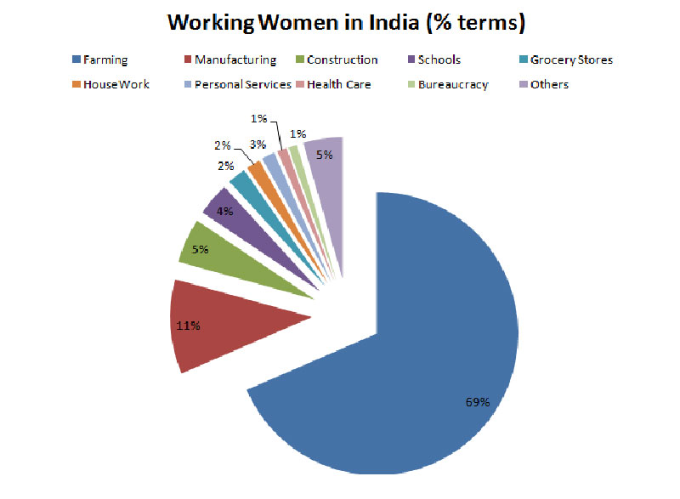

The educational and occupational ‘patterns have also changed and widened with women entering the domains, which till decade back was considered to be dominated by men. There has been an encouraging rise in the percentage of women joining service sector specially Banking and IT.

Women have played a silent, self-effacing role to sustain Indian civilization down the ages. They have made their influence felt in all walks of life but retained the feminine graces-motherliness, wife’s fidelity, kinship bonds, cultural norms and the cherished “home sweet home” instinct.

Download Here

Article on Modern Indian Woman Educated Empowered and Emancipated
role of women in economic development of india, women's place in indian society today, essay on modern indian woman in hindi, women's contribution in indian economy, article on modern indian woman educated empowered and emancipated, women's contribution to society, women's role in society past and present, women's contribution in economy, role of women in economic growth and development, women's role in economic development summary, women's role in economic development pdf, women's role in economic development book, women's role in economic development boserup, role of women in social and economic development of india, women's contribution to gdp in india, women's role in india's development, women's contribution to society today, economic contribution example, woman’s role in economic development, great womens of indian history, great womens of india achievements,

