Essay on Uses of Internet in Our Daily Life Advantages and Disadvantages

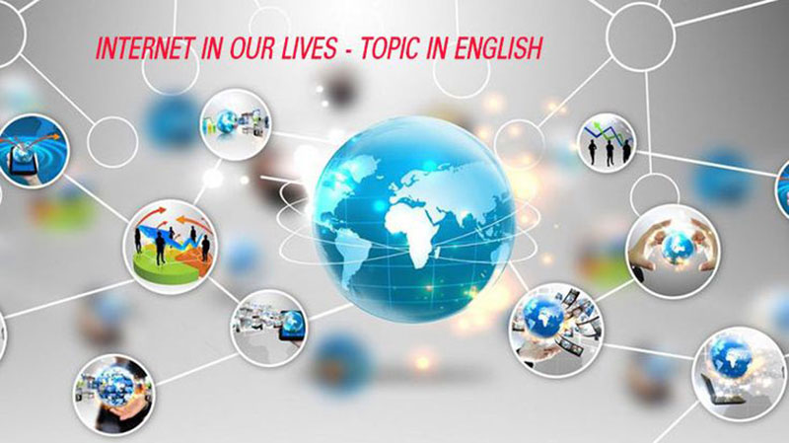

Internet is the logical conglomeration of computer systems that are spread around the world. It has been created with the help of optical cable networks, modem devices, telephone lines, LAN and WAN networks and satellites. Information is displayed on various web sites on Internet. This information is related to almost every area of human endeavour, including environment, space and facts related to the cosmos.

In Internet jargon, if a person opens - Internet web sites on his computer (or surfs through the web sites), then he is called Netizen. Presently, there are nearly 45,00,000 Internet connections in India. But vis-a-vis 1.5 million connections operating in the West, this number is very timid. Internet is a boon for a nation like India. It helps us exchange vital information and data and our readers know that in the present information technology age, information is everything. Almost all the governments of the world, private firms, non-government organisationand professionals either want to go their web sites developed or surf through various Internet web sites. Many of them have got their web sites developed and also got them uploaded on this wonderful information superhighway. Not only this, there are web sites of many newspapers, magazines and technical journals as well.

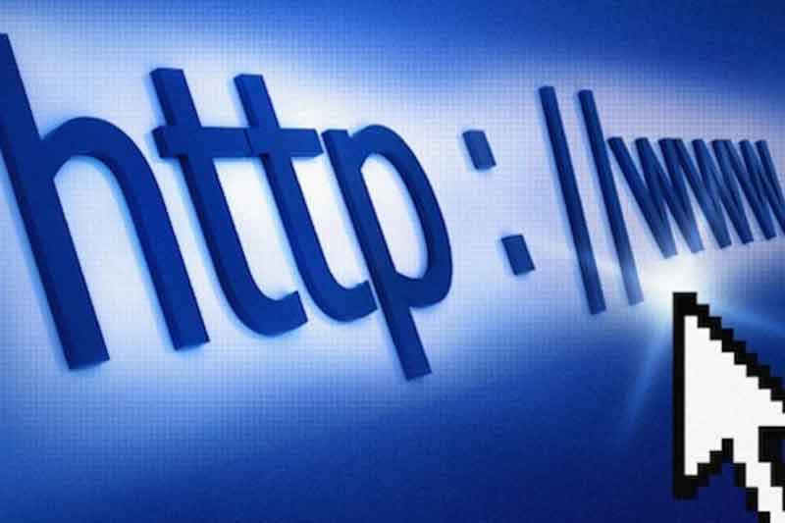

This method of information exchange is very efficient and fast. E-mail can be used by Netizens to send information to any part of the world. Voice, data, video information and information in the form of text can be sent from one computer to another with ease. Besides, Internet has put man on the peak of the business world. This concept is called Electronic Commerce (E-com). Electronic Commerce is related to the exchange of goods and services through the Net and in this system, money is not physically transferred. It is transferred through a new system, which is called Electronic Cash (E-cash). We can buy and sell practically anything through Internet; exchange of data for engineering projects is also included in this system. There are three levels of connectivity of Internet. The first level is Ti in which, the user can only see the information/data put on various web sites. The second ‘evel is T2 in which, he can create his own web sites as well as collect information from the Net.

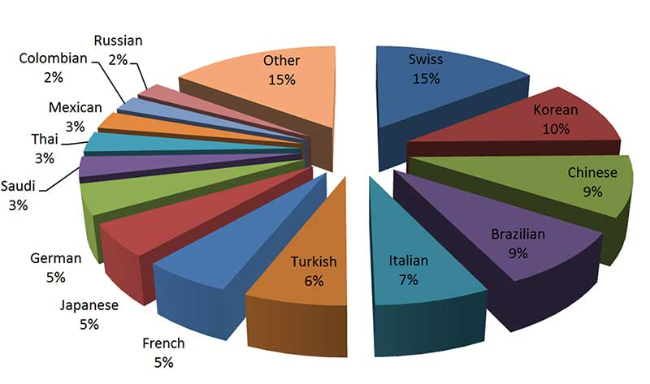

The third level is T3 in which, he himself becomes a part of the Internet System. Nowadays, VSNL, Mantra Online and Satyam Online are the three major Internet Service Providers (ISPs). Many other firms are entering the vast markets related to Internet services. VSNL has been privatised now. Internet affects all the areas of human endeavour. It has been successful in earning valuable achievements in fields like education, entertainment, sports and games, science and technology, Electronic Commerce and social interactions (like marriage alliances). This world has already taken the shape of a small village. The prices of Internet services are falling. Internet connectivity can be obtained by paying just Rs. 525 on an annual basis. But in addition to this, we would need a computer (Pentium-800 system), software for running programs of Internet, one telephone line and a modem device. The government has provided local dial-up service in all the districts of the country.

A user, who is located within the 100-kilometer radius of an ISP, can use Internet services through a local telephone line. In order to surf through Internet, we have to connect our computer system to the main information gateway of the ISP through a telephone line and modem. We use Internet navigation software to surf through Internet. These programs are provided by Microsoft Corporation (Internet Explorer) or Netscape (Netscape Navigator). Dialling is automatic over the telephone and if a connection is made, then we arrive at the main menu of the ISP. We can surf through any web site if we feed its correct URL on the computer’s screen at the command line. We can surf through various web sites, send and receive E-mail, read magazines and even listen to music.

There is also a lot of garbage like information on the Net, which is related to obscene photographs and movies. It is sad to note that the youth of today do not use Internet for educational purposes, or for enhancing their professional capabilities. This tendency ought to be given a U-turn. In sum, Internet would become a dominant force in the areas related to professional, social, business and entertainment activities of all the people in this century.

Download Here Essay On Internet Advantages And Disadvantages
essay on internet advantages and disadvantages, essay on internet and its uses, short essay on importance of internet, sample essay advantages internet, essay on uses of internet in our daily life, short paragraph on internet, internet good or bad essay, internet essay introduction, uses of internet for students, paragraph on internet in 100 words, short speech on internet, essay on internet in english,

