My Best Friend Essay or Paragraph

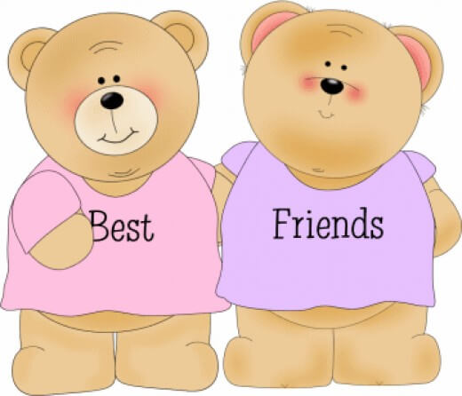

A friend in need is a friend indeed. The world looks dark without a true friend. Happy are those who have a true friend. I am lucky to have a true friend in Ajay. He belongs to a noble family. He is my class – fellow. We work, play and study together. He is good at studies.

He always stands first in the class. He is also a good player of hockey. He is the captain of junior hockey eleven. He has many qualities of head and heart. He is always regular. He is never late for school. He keeps neat and clean. He is honest and truthful. These qualities have endeared him to all. He takes exercise in the morning. He helps me in studies. He is an ideal friend. Both of us like each – other.
Download here: My Best Friend Essay in PDF
For more Essay and Story visit here http://www.english.makeaneasy.com

