Short Story of the Tailor and the Elephant
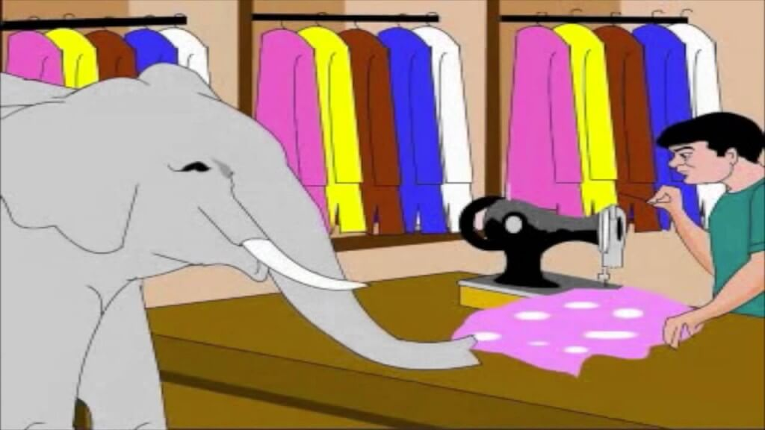
A King Had An Elephant. He Was Daily Taken To A Stream For A Bath. There Was A Tailor's Shop On The Way. The Tailor Was A Gentleman. The Elephant Stopped At His Shop And The Tailor Gave Him Something To Eat. This Went On For A Long Time.
One Day the Tailor Had A Quarrel With One Of His Customers. So Was In An Angry Mood. The Elephant Came There As Usual. The Elephant Felt Pain, But He Withdrew His Trunk and Went Away.
After His Bath, The Elephant Filled His Trunk With Muddy Water. On His Way Back He Threw It Into The Tailor's Shop. The Tailor Soon Understood Why The Elephant Had Behaved Like That. But Then It Was Too Late.

Moral: Tit For Tat.

Download here other moral story for kids

Short Story of the Tailor and the Elephant in PDF

Searches related to The Tailor and The Elephant, elephant and tailor story pdf, elephant and tailor story images, tit for tat essay, the elephant and the tailor moral, elephant and tailor story in english, elephant and tailor story with pictures

