Good Manners Short Essay in English for Student
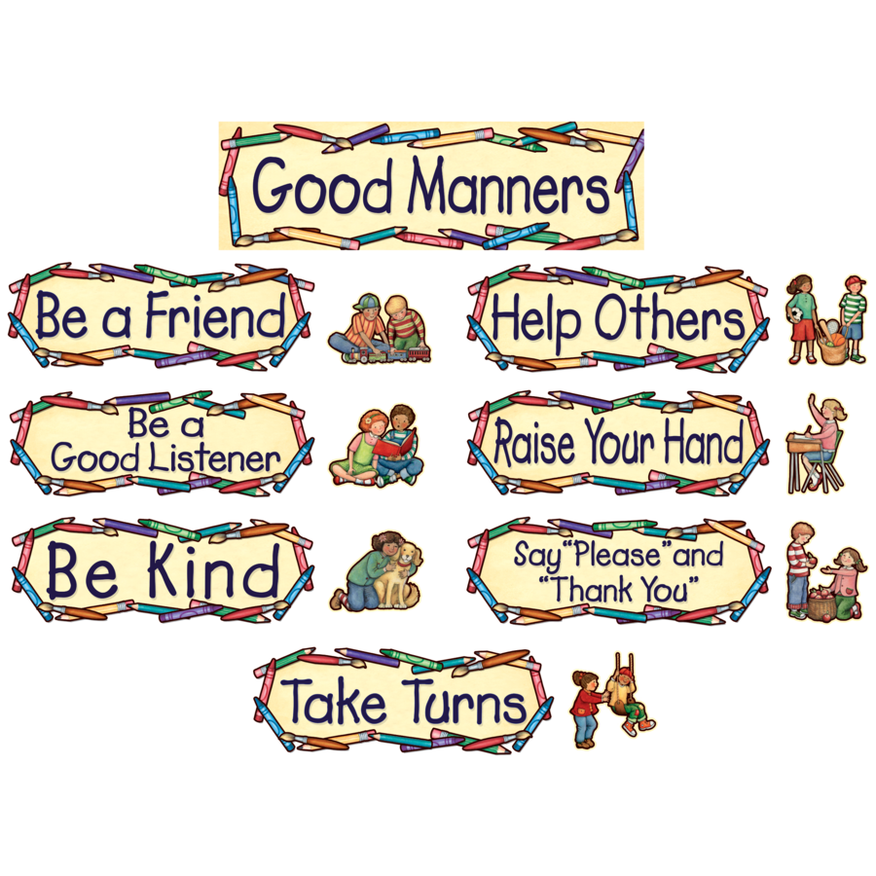
Manners make a man. They should be observed in every walk of life. At home we should respect our elders and love our younger’s. We should co – operate with each other in doing household work. We should entertain the guests who visit us.
At school we should respect our teachers. We should not make a mischief in the class. We should maintain discipline. We should be helpful to those students who are weak. We should treat all as equals.
If we are in a company, we should talk less and listen more. We should not hurt the feelings of others. Whenever somebody does us a favor, we should use the words “please” and “thank you” Good manners cost nothing, but win everything.
Download here:
Good Manners Short Essay in PDF
Read here more essay. http://www.english.makeaneasy.com/category/paragraphs/
Searches related to good manners essay: essay on good manners for class 2, good manners speech, short paragraph on good manners, essay on good manners for class 4, about good manners, 10 lines on good manners, good manners essay for children's, importance of good manners in student life

