Essay on Hostel Life of a Student
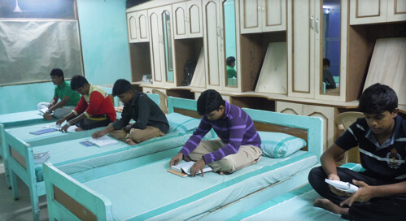
Hostel life is both a boon as well as a curse. It has many advantages. A student can pursue his studies further in another city. He becomes independent. He can study at will, play at will and rest at will. He is free to make his own decisions.
He finds enough time at his disposal to study hard. He learns the habit of handling money. He is free in spending, wasting or saving money.He learns the habit of living in a group. It makes him social and co-operative. Hostel life has certain disadvantages also. The student enjoys unlicensed freedom. He lacks all check and control from the side of parents.
There are ample chances of his getting into silly and bad habits. He faces the worst situation when he falls ill or faces some other difficulty. His family members cannot support him on such occasions. By remaining lonely, he may feel neglected and turn out to be an incorrigible and undesirable citizen.

Download here other Essay
http://www.english.makeaneasy.com/category/paragraphs/
Searches related to hostel life essay, disadvantages of hostel life essay, hostel life of students, my hostel life speech, essay on hostel life with quotations, hostel life experience, paragraph on my hostel life, hostel life quotes, hostel life vs home life, paragraph on hostel life, hostel life speech, essay on advantage and disadvantage of hostel life, speech on hostel life, articles on hostel life, essay on hostel life of a student in hindi, hostel life essay pdf

