God Mercury and The Woodcutter Story
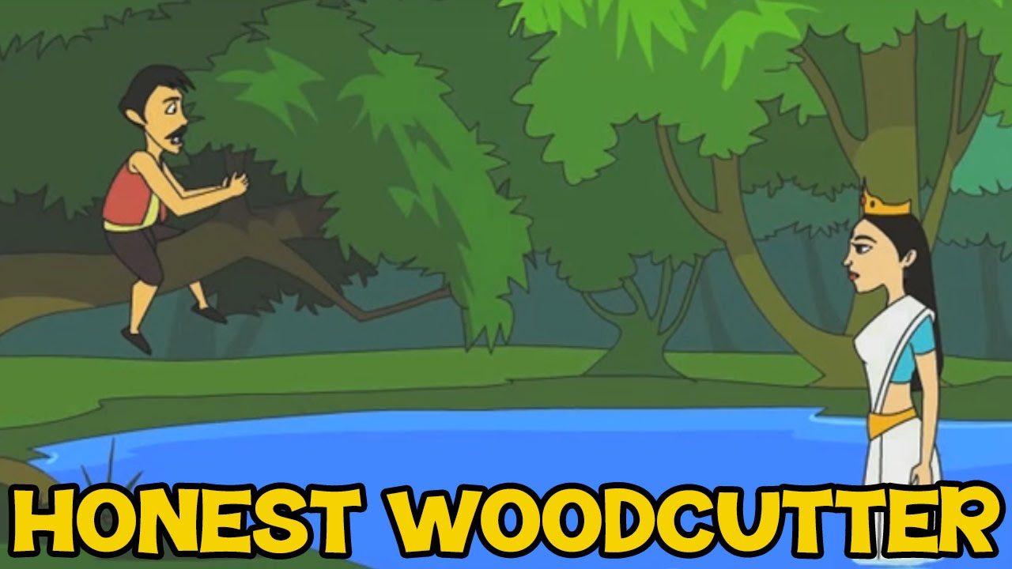
Once a wood-cutter was felling a tree at the bank of a river. By chance his axe fell into the water. He began to weep. The god mercury heard his cries. He appeared before him and said, “why are you weeping?” The wood-cutter told him the whole story.
The God dived. Soon he came out with a golden axe. The wood-cutter said. “Sir it is not my axe. My axe was not so beautiful.” Then the god dived again. He came out with a silver axe. The wood-cutter said, “Sir, it is not mine. My axe was not so shining.”
The God dived for the third time. He came out with an iron axe. The wood-cutter felt very happy. He said, “This is mine. How should I thank you?” The God was pleased at his honesty. He gave him all the three axes as a reward.
Moral: Honesty is the best policy.
Download here other Popular Stories in PDF.
http://www.english.makeaneasy.com/category/stories/
Searches related to God Mercury and The Woodcutter Story, honest woodcutter story in english, the woodcutter and the axe story with moral, honest woodcutter story in english pdf, honest woodcutter story in english with pictures, the honest woodcutter full story, the honest woodcutter story book, honest woodcutter story pdf, honest woodcutter story images, the honest woodman story, story of woodcutter and tree, the honest woodcutter summary, woodcutter sharpen axe story, the honest woodcutter short story, the honest woodcutter story with pictures, honest woodcutter script, the honest woodcutter plot, the honest woodcutter characters, story of woodcutter in english, dialogue between tree and woodcutter, two woodcutters story, foolish woodcutter story, the tree and the woodcutter script, woodcutter and the most beautiful tree

