Cap Seller and Monkey Story in English with Moral

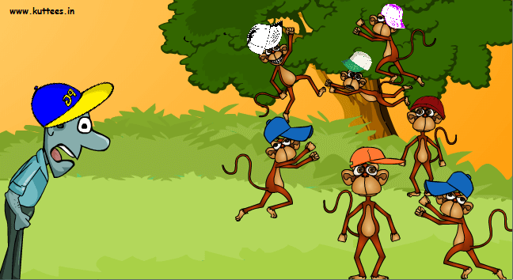
Once a cap seller went to a village to sell his caps. On the way he felt hot and tired. He sat under a shady tree. He put the bundle beside him. He lay down to take rest. Soon he fell fast asleep.
Some monkeys lived in that tree. They climbed down. They tore open the bundle. They took away the caps. They wore the caps on their heads. Now they began to jumps about.
The cap seller woke up. He found his caps missing. By chance he looked up. He saw the monkeys wearing his caps. The cap seller became sad. But he did not lose is presence of mind. He knew that the monkeys imitate.
He hit upon a plan to get back his caps. He took off his own cap. He threw it down on the ground. The monkeys did the same. The cap seller gathered his caps. He thanked God and went on his way.
Download here other Stories:
http://www.english.makeaneasy.com/category/stories/
Searches related to the cap seller and the monkeys, the clever cap seller story in english, the cap seller and the monkey story with pictures, cap seller and monkey story in english written, cap seller and monkey story free download, the cap seller and the monkey short story in english, the cap seller and the monkey story in english free download, cap seller and monkey story in english with moral

